LAPORAN PRAKTIKUM PENGOLAHAN CITRA DIGITAL
9. CONVOLUTION AND CORRELATION



Disusun oleh :
Nama : Felix
NPM : 2327250059
Kelas : IF41

PROGRAM STUDI INFORMATIKA
FAKULTAS ILMU KOMPUTER DAN REKAYASA
UNIVERSITAS MULTI DATA PALEMBANG
2025
TUTORIAL : CONVOLUTION AND CORRELATION

Goal
The goal of this tutorial is to learn how to perform a correlation and convolution
calculations in MATLAB.

Objectives
- Learn how to perform a correlation of two (1D and 2D) matrices.
- Learn how to perform a convolution of two (1D and 2D) matrices.
- Explore the imfilter function to perform correlation and convolution in MATLAB.

Procedure
We shall start by exploring convolution and correlation in one dimension. This can be achieved by means of the imfilter function.
- Specify the two matrices to be used.
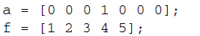
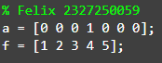

- Perform convolution, using a as the input matrix and f as the filter.
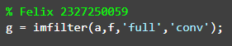
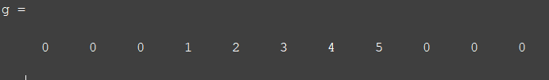

Question 1 What is the relationship between the size of the output matrix, the size of the original matrix, and the length of the filter?
Ukuran matriks hasil (g) adalah n+m−1, yaitu jumlah panjang matriks input a dan filter f dikurangi satu. Matriks hasil mencerminkan hasil konvolusi, yang merupakan gabungan nilai-nilai hasil operasi pergeseran dan perkalian elemen filter dengan elemen dari a, bukan hanya salinan dari isi a dan f.

Question 2 How does changing the third parameter from ’full’ to ’same’ affect the output?
Perbedaan menggunakan same adalah ukuran dari array a dan menggunakan konsep konvolusi yang merupakan gambungan nilai-nilai hasil operasi pergeseran.

- Perform correlation on the same set of matrices.
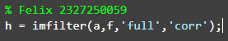
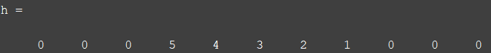

The results from the previous step should confirm that convolution is related to correlation by a reflection of the filter matrix, regardless of the number of dimensions involved. Let us see how correlation works on a small window of size 3 × 3. Consider the window of values extracted from a larger image in Figure 9.1. The correlation of two matrices is a sum of products. Numerically, the calculation would be as follows:
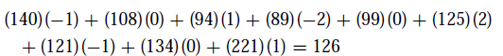
Here, we specify the image (which in our case will be the image region as in
Figure 9.1) and the mask from Figure 9.2. We will also explicitly tell the function to use correlation, as it can perform both correlation and convolution.
FIGURE 9.1 A 3 × 3 image region.

FIGURE 9.2 A 3 × 3 mask.

- Clear all workspace variables.
- Use imfilter to perform a correlation of the two matrices.
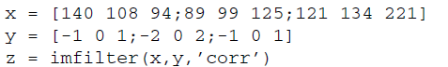
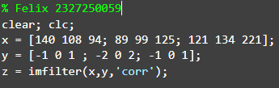
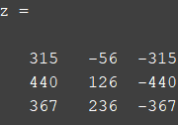

Question 3 In the resulting matrix (z), we are interested only in the center value. How does this value compare with our calculation illustrated above?
Kalikan saja langusung
140×(−1)+108×0+94×1+89×(−2)+99×0+125×2+121×(−1)+134×0+221×1 = -126, karena itu nilai tengahnya -126

Question 4 What are the other values in the resulting matrix?
Kita memiliki matiks seperti berikut
x = [140 108 94;
89 99 125;
121 134 221]
Bila ingin mencari nilai dari hasil z
z =[? -56 -315;
440 126 -440;
367 236 -367]

Bila ingi mencari nilai z(1,1) atau tanda tanya(?)
Maka tinggal lakukan perkalian, nanti dengan matriks x-nya seperti ini
X = [0 0 0;
0 140 108 ;
0 89 99]
Lalu dilakilan saja dengan kernelnya atai dengan matriks y, kenapa matisk x bisa menjadi seperti itu karena matlab menggunakan cara perkalian same yang Dimana kalikan saja bila ingin mencari nilai z(1,1) maka nilai x (1,1) berada di Tengah matriks lalu area yang lain tinggal ikuti saja.

Question 5 Note in the last step we did not specify if the output should be ’full’ or ’same’. What is the default for this setting if it is not specified?
Default dari setting tersebut adalah same.

To perform convolution,weuse the same technique as in correlation. The difference here is that the filter matrix is rotated 180◦ before performing the sum of products. Again, the calculation of the convolution of the given image region and mask is performed as follows:

- Use imfilter to perform a convolution of the two matrices.

Question 6 How does the center value of the resulting matrix compare with our calculation above?
Sama saja nilai tengahnya, akan tetapi hal tersebut hanyalah kebetulan karena ‘conv’ kernel (y) harus di balik terlebih dahulu x lalu y.

